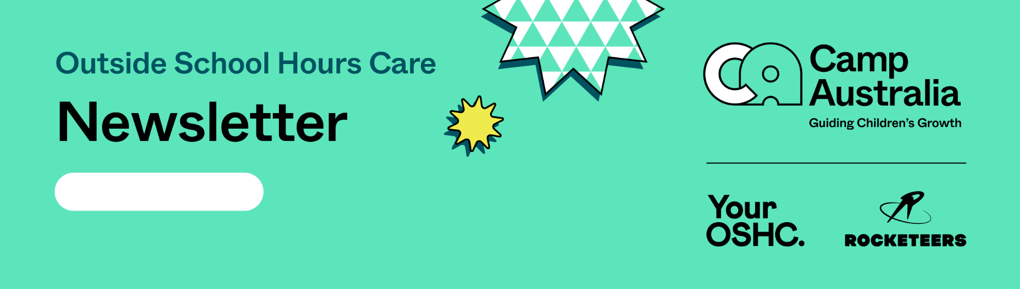
10.08.2026

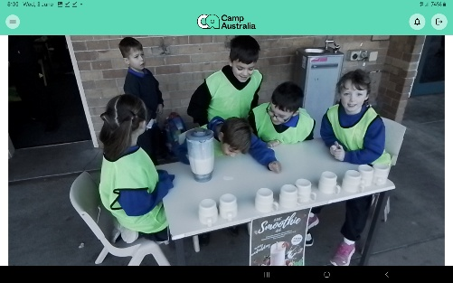
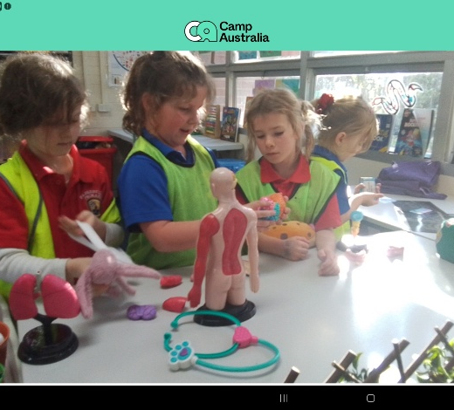
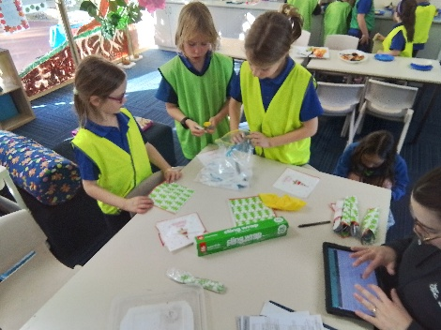
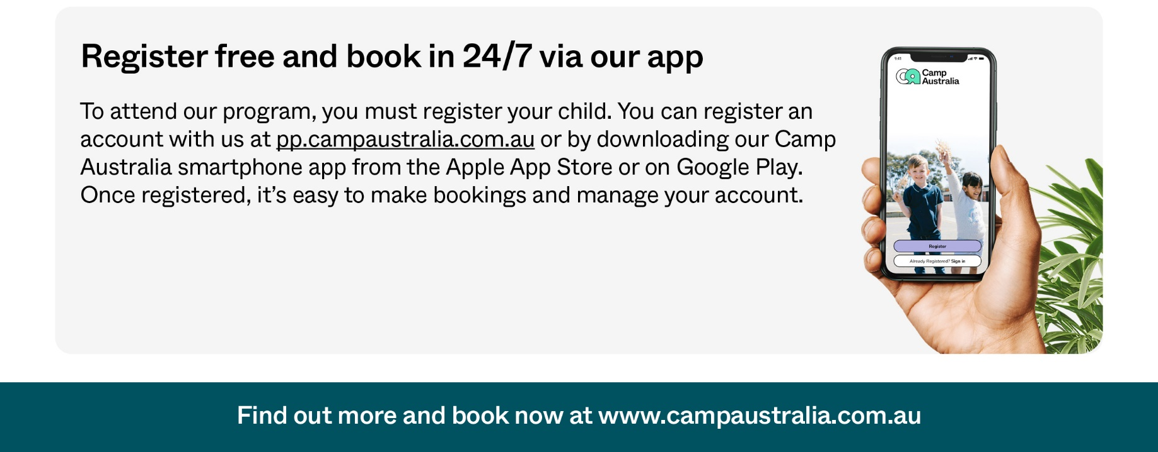


Children this week at OSHC will be engaging in a Themed Program of ‘Colours’. Children will have fun amazing activities and experiences, creating a recycled collage Sun, further extend their learning and knowledge around colours, by exploring the Rainbow Colour Wheel, seeing what colours put together create other colours. Children can enjoy Big Art Fridays, creating Redgum Prints and extend their engineering and construction skills through Lego challenges, creating LEGO Ice Castles. Children were observed last week to continue to show amazing meaningful community spirit and engagement running the OSHC Smoothie Breakfast Club, for children who may not have had breakfast before school and also an educator and children collectively wrapping utensils to be donated to community services organisations, for food and soup kitchens, to be given to people experiencing homelessness. This initiative provides children with an authentic opportunity to contribute to food drives and food bank initiatives while developing an understanding of community needs and the importance of supporting others. The resources being prepared had been generously donated by families, the school and members of the wider community, demonstrating a strong sense of collective responsibility, partnership and community connection. Conversations between educators and children demonstrated a strong level of understanding and knowledge about the purpose of their contribution where children were able to make connections between their actions and the positive impact they could have on others. They demonstrated an emerging understanding that their contributions, regardless of their size, can assist people within their wider community.
UPCOMING PROGRAM HIGHLIGHTS
. 3D Paper Pineapple
. Poison Ball – Group game.
MENU HIGHLIGHTS
. Blueberry / Berries Smoothies
. Honey Joys
Your OSHC Team Julie, Renee and Lana.
PARKERVILE PRIMARY SCHOOL

