
11.5.2026

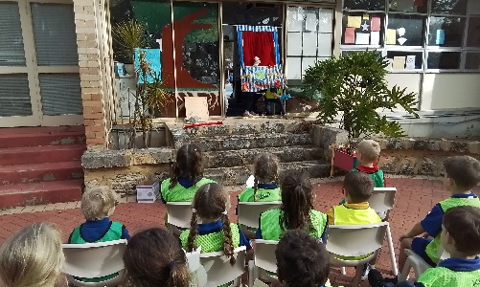
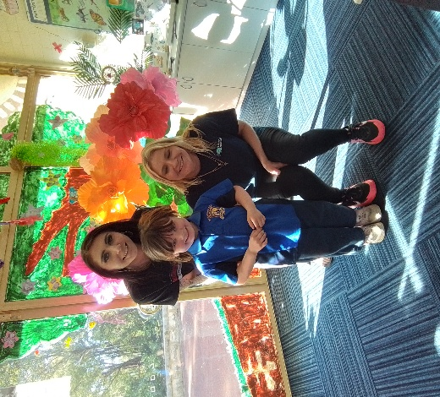
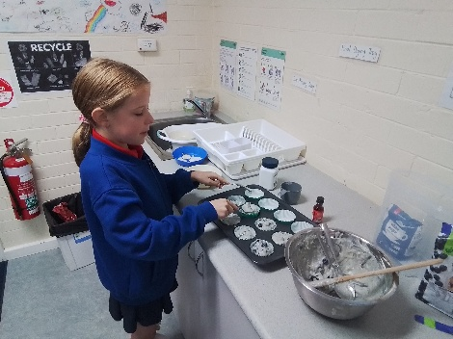



Children have been having an amazing time at OSHC this term, with children celebrating ‘Mother’s Day’ themed program last week, celebrating their mums/ significant care giver. Children enjoyed making personalised Mother’s Day cards, arts and crafts hand made gifts, setting up a Flower Photo Booth area, for children to have a Mother’s Day photo with their mum, when they were at OSHC. Children showed great enthusiasm, preparing a High Tea afternoon tea for their mums to come and be spoilt, receiving gifts, blue berry muffins and biscuits the children had made. This week’s program theme is ‘National Families Week’, with children engaging in fun experiences and activities, celebrating their families and use opportunities to participate in and develop understandings of diverse cultures, heritages, backgrounds, traditions and family structures. In the upcoming weeks, program themes are ‘Big Art’ week and Reconciliation week. Children will be able to engage in activities and experiences, making a nature collage, recycled material construction and make their own playdough and put in a picture for the Big Art Comp. Children will also be celebrating Reconciliation week, with the Reconciliation theme ‘All In’, creating their own reconciliation mobile with artwork, spiral snakes and extending their knowledge and understanding about Bush Tucker, making a group Reconciliation Week Banner.
UPCOMING PROGRAM HIGHLIGHTS
Animal Scavenger Hunt
Indigenous Animals Collage
MENU HIGHLIGHTS
Vegemite Cheese Scrolls
Wattle Seed Damper.
Your OSHC Team Julie and Renee
PARKERVILE PRIMARY SCHOOL

