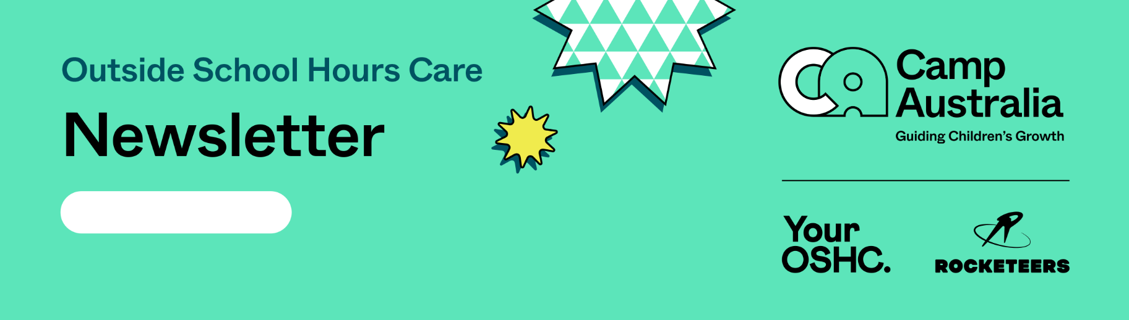
9.03.2026

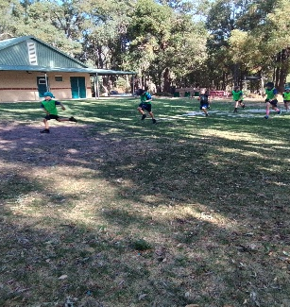
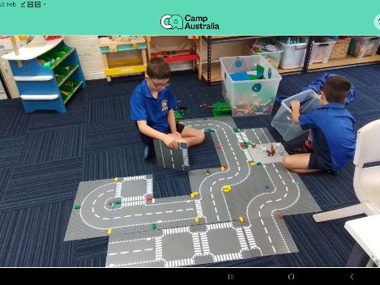
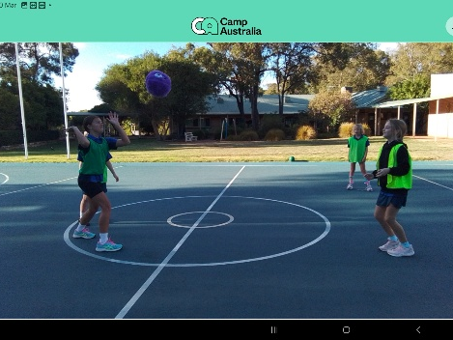
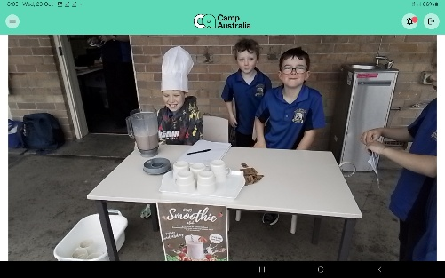
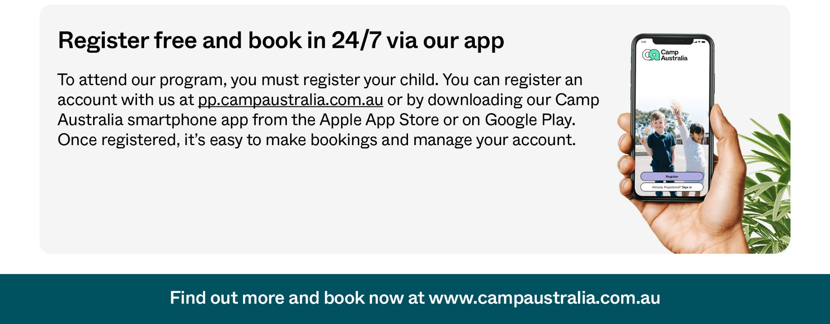



Children have been observed to show amazing engagement in planned experiences and activities, with all children observed to confidently explore and engage with social and physical environments through relationships and play. Children this week have enjoyed Theme, Autumn, with children actively involved in experiences and activities, paper plate Autumn Leaf Lions, Autumn Nature Scavenger Hunt, Lego Challenges and Big Art Fridays, food collage and learn about recycling, repurposing old newsletters with watercolour paint to make an Owl.
Children continue to be actively involved in their community, being community helpers every Wednesday mornings, facilitating and running the OSCH Breakfast Smoothie Club, making healthy fruit smoothies, for children who may have come to school and haven’t had breakfast. Amazing attendance from children within the school community, all enjoying Healthy Fruit Smoothies.
Children next week, will be celebrating ‘Superheroes’, with children engaging in arts and crafts, recycling activities, Lego challenges and Superhero Training, all being able to show interest in other children and young people and being part of a group.

UPCOMING EXPERIENCES:
- Pipe Cleaner Superheroes.
- Lego Challenge – Build you own Lego Superhero.
- BA: Ninja – Children to design their own Ninja.

MENU HIGHLIGHTS:
. Vegemite/ Cheese Scrolls.
. Honey Joys.

We are open for the upcoming Pupil Free Day:
Monday 30th March 2026 – 6 am – 6pm.

Your OSHC Team,
Julie & Renee.

Your OSHC Team Julie and Renee
PARKERVILE PRIMARY SCHOOL

